**[Five coloring theorem proof](Tatsuno_1.pdf)**

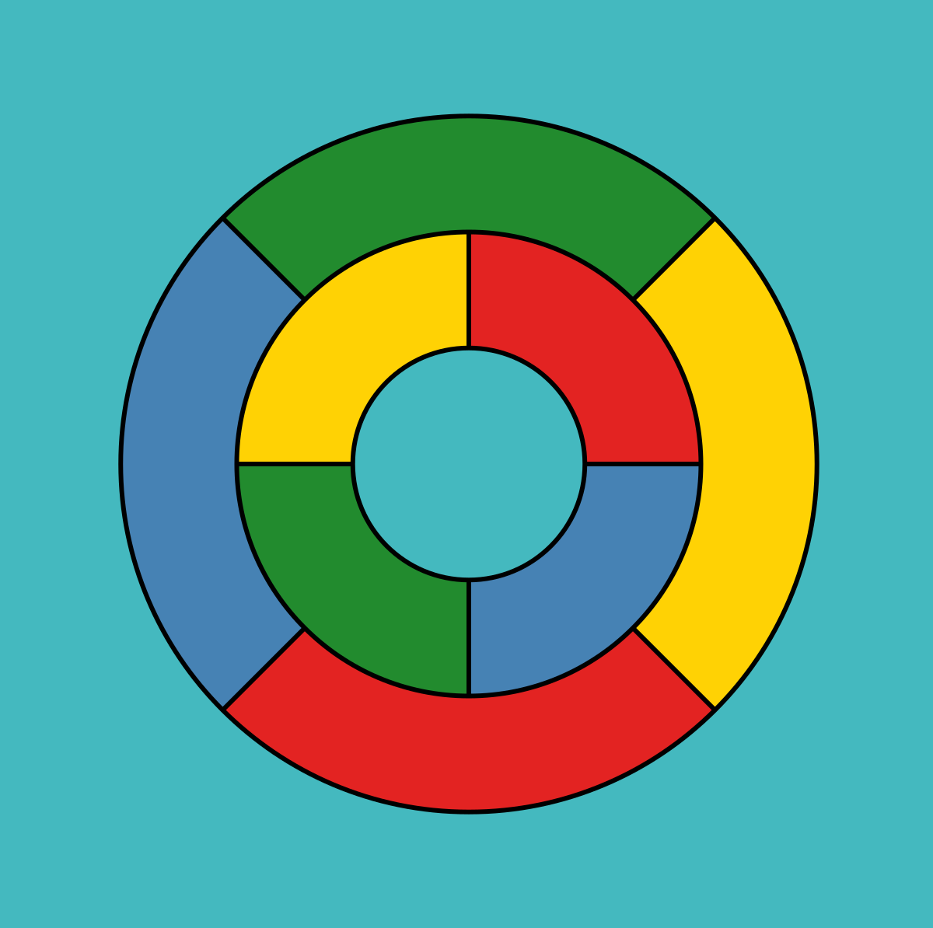

**Student Id: 21110241**

**Student name : issam awamleh**

**Instructor : rola musleh**

**Section :4**

**The proofs mentioned in the sentence you provided refer to the 4-color theorem and the 5-color theorem. This passage presents the proof of Theorem 1.1, his five-color theorem for planar graphs without loops.**

**Here is the evidence submitted:**

**Evidence for Claim 1:**

**This proof uses the contradictory argument to show that there exists a vertex v of degree (number of incident edges) 5 or less in the graph. Assuming that all vertices have a degree of at least 6, we derive a contradiction by considering the number of edges in the graph.**

**Evidence for Claim 2:**

**This proof shows that if there is a path P between vertices v1 and v3 of subgraph H − {v2, v4}, then there is no path between v2 and v4 of subgraph H − P. The concept of cycles in the figure and the behavior of the figure around v2 and v4 are used to support this claim.**

**Evidence for Claim 3:**

**This proof shows that claim 3 holds if the component C1 of H1,3 (the subgraph induced by the 1 or 3 vertices of color) containing v1 also contains v3. Furthermore, considering the case where C1 does not contain v3, it is shown that a valid 5-color coloring can be achieved by swapping colors and assigning new colors to specific vertices.**

**These proofs are an important step in establishing the validity of the five-color theorem for loop-free planar graphs. They provide evidence and justification for the claim that such a 5-color diagram can be colored such that no two adjacent vertices have the same color.**

**Claim 1:**

**Simplification:**

**Let's assume G is a graph since multiple edges do not affect coloring and each pair of vertices is connected at most to one edge.**

**Connectedness:**

**G let be connected and the theorem can be proved for the connected graph and that benefits to focus on the abilities to color connected simple graphs.**

**Indicative:**

**The author keeps using the induction argument for the vertices that we assume has the value |V| the base case established which is |V|<= 5 then the graph can easily have done with 5 colors with give every vertex a special color.**

**Inductive step:**

**This is the primary step in which the author assumes that |V|=n and tries to |V|=n+1.**

**Claim1 degree of the vertex:**

**The claim is v (belong to) V with the degree deg(v)<= 5 and that considers the contradiction of the claim that has been put which is every vertex can handle degrees which is at least 6 and the contradiction is the number of edges between the two claims.**

**graph with at least 6 degrees The most important observation is that every vertex has at least 6 edges, and 1 edge is shared by exactly 2 vertices. This means that the sum of the degrees of all vertices is at least 6 times the number of vertices, denoted 6|V|.**

**on the other hand, G is a connected simple graph with at least 3 vertices |v|>=3 it clearly shows the number of edges |E|<=3|v|-6.**

**Explanation: The inequality |E| ≤ 3|V| - 6 is derived from a result known as Euler's formula for planar graphs, which states that for a connected planar graph with V vertices, E edges, and F faces: V - E + F = 2.**

**The combination of the 2 pieces and we get this relation:**

**Using the fact that each edge contributes to the degree of exactly two vertices, we can write Σdeg(v) = 2|E| (each edge contributes 2 to the total sum of degrees).**

**Substituting this into the first inequality, we get 2|E| ≥ 6|V|, which can be simplified to |E| ≥ 3|V|.**

**But these two lead to contradiction let's see:**

**|E| ≥ 3|V|.**

**|E|<=3|v|-6.**

**3|V|<=3|v|-6**

**0<=-6**

**The inequality 0 ≤ -12 is clearly false, and this contradiction arises from the assumption that deg(v) ≥ 6 for all vertices v. So this assumption is wrong and there must be at least one vertex v of degree deg(v). ≤ 5.**

**Claim 2:**

**To prove this claim, the author first introduces a circle C that is uniquely determined in graph G and formed by the vertices v, v1, P, v3. The purpose is to show that there is no path between v2 and v4 in Figures G-C.**

**G: Represents the graph under consideration, which is a loopless plane graph.**

**V: Represents the set of vertices in the graph**

**G. E: Represents the set of edges in the graph**

**G. v: Represents a vertex in the graph**

**G. x, y: Represents vertices in the graph G that form an edge (x, y).**

**H: Represents a subgraph of G obtained by removing a vertex**

**v. P: Represents a path between vertices v1 and v3 in the subgraph H - {v2, v4}.**

**C: Represents a cycle in graph G, specifically the cycle vv1Pv3v.**

**VC: Represents the set of all vertices contained in the cycle C.**

**Q: Represents a path between vertices v2 and v4 in the subgraph G - C.**

**A: Represents a bounded open set in the plane R^2, complement of the cycle C.**

**B: Represents an unbounded open set in the plane R^2, the complement of the cycle C.**

**The process is:**

**1_Let assume Q is a path between v2_v4 in group G-C.**

**Since Q is still the path in H-P that means the path between the v2_v4 in H-P._2**

**And if the Q it does not exist in H-P so the v2-v4 does not exist as well in H-P._3**

**4_Let's consider two points x2 is a subset s2 and x4 is subset of s4, s4 and s2 are edges on the cycle c**

**5_C is a non-self-intersection closed path in R^2-C by the Jordan curve theorem and that theorem divides in to components a bounded open set which is A and a non-bounded open set which is B.**

**Explanation: the division is represented as an interior region and an exterior region. The interior region is a bounded open set, while the exterior region is an unbounded open set.: an interior region and an exterior region. The interior region is a bounded open set, while the exterior region is an unbounded open set.**

**Since x2 belongs to A and x4 belongs to B so it can't exist in a path in R^2_C between x2 and x4. _6**

**7_ if there is a path between the x2 and x4 in G-C it can contradict the fact of the belonging of x2 in A and x4 in B.**

**8_in conclusion there is no path between the v2 and v4 in G-C which proves the claim.**

**What's the benefits in 5 coloring theorem?**

**The advantage of 5 colors becomes clear when considering the restrictions imposed by the color scheme. Pentacolism helps create distinct regions or partitions in a graph by ensuring that adjacent vertices have different colors. Using this splitting property, we can argue that if there is a path between v1 and v3 in H − {v2,v4}, then there cannot be a path between v2 and v4 in the same subgraph. A color scheme effectively separates these paths and limits their interaction.**

**Claim 3:**

**This proof demonstrates that if the component C1 of H1,3 (subgraph induced by vertices colored 1 or 3) containing v1 also contains v3, then Claim 3 holds. It further considers the case where C1 does not contain v3 and shows that by interchanging colors and assigning new colors to certain vertices, a valid 5-coloring can still be achieved.**

**H: The original graph.**

**C1: The component of H1,3 containing v1.**

**v1, v3: Vertices in the graph.**

**P: The path between v1 and v3 in the subgraph H - {v2, v4}.**

**C2: The component of H2,4 containing v2.**

**v2, v4: Vertices in the graph.**

**The process:**

**1_ Consider the component C1 of H1,3 containing v1. If C1 also contains v3, then Claim 3 holds.**

**2_supose that C1 does not contain V3 swap both colors 3 and 1 in all vertex of C1 in result another valid 5 coloring of H so we got V1 and v3 is colored 3 in this new coloring.**

**3_ allocate color 1 to the vertex v. Since we have v1 and v3 colored 3, so v can have the color 1.**

**4_let's move to the components of C2 of H2,4 containing v2 without v4 and if it contradicts the previous claim.**

**5_we assign the colors 2 and 4 for C2, creating a different valid 5 coloring of H. This new coloring has w and v4 with color 4.**

**6_since the v4 isn't in the C2, vs and v4 are both assigned color 4 of the new coloring.**

**7_ so v no longer has a neighbor colored 2 allowing us to allocate color 2 to v.**

**8_ Successfully assigning colors to v, v1, v2, v3, and v4 in the modified coloring showed that H is indeed 5-color-capable.**

Reference:

[Die] R. Diestel, Graph theory, Fifth edition, Springer, 2017 [1] https://en.wikipedia.org/wiki/Five_color_theorem